**Published paper certificate**

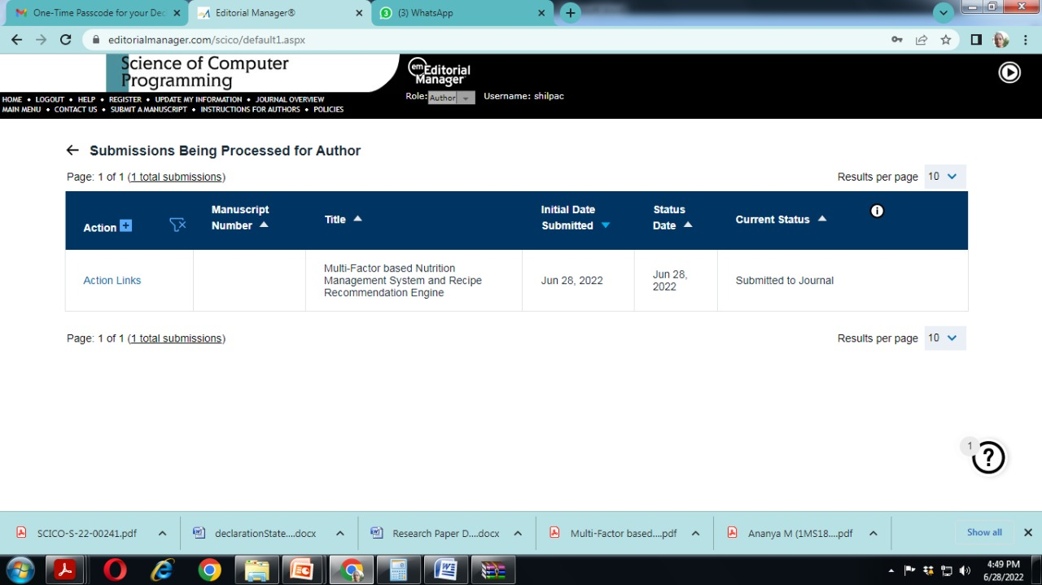

The research paper has been submitted to the web of science journal.